Multiple-choice section – choose the correct answer

Question 1 [9.1]

Which of the following is not a quadratic equation?

**A** y = *x*2 + 5*x* – 3 **B** y = -3*x* 2 + 3*x* + 6 **C** y = 25 – 4*x* 2 + 2 **D** y = 7*x* 3 + 16*x* – 2

Question 2 [9.3]

To obtain the graph of *y* = (*x –* 2)2 + 4, the graph *y* = *x*2 is translated:

**A** 2 units to the left and 4 units up

**B** 2 units to the right and 4 units up

**C** 2 units to the left and 4 units down

**D**  2 units to the right and 4 units down

Question 3 [9.1]

The graph below is an example of:

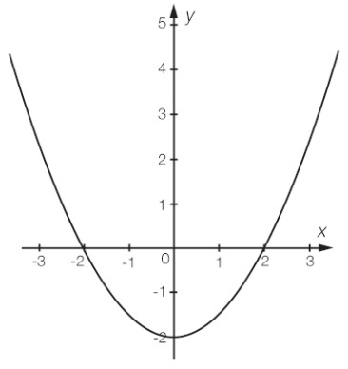

**A** a parabola **B** an exponential **C** acircle **D** a hyperbola

Question 4 [9.3]

The dilation factor for *y* = -7*x*2 – 5 is:

**A** 5 **B** 2 **C** -7 **D** 7



Question 5 [9.4]

Which of the following equations would graph as a circle?

**A** *x* + *y*2 = 81 **B** *x*2 + *y* = 25 **C** *x*2 + *y*2 = 4 **D** *xy* = 100

Question 6 [9.2]

The solution to *x*(*x* + 12) = 0 is:

**A** *x* = 0 or 12 **B** *x* = -12 **C** *x* = 12 **D** *x* = 0 or -12

Question 7 [9.6]

Find the equation for this table of values.

|  |  |  |  |  |
| --- | --- | --- | --- | --- |
| *x* | 0 | 6 | 12 | 18 |
| *y* | 0 | 1 | 2 | 3 |

**A**  *y* = *x* **B** *y* = 6*x* **C**  *y* = 3*x* **D** *yx*2 = 6



Question 8 [9.4]

What is the centre and radius of the circle with the equation (*x –* 3)2 + *y*2 = 121?

**A** (-3, 0), 11 **B** (3, 0), 11 **C** (3, 0), 121 **D** (3, 0), 121

Question 9 [9.5]

Which equation will not graph a hyperbola?

**A** *xy* = 5 **B** *y* = + 6 **C** *y* = 3 – **D** *y* = – 2



Question 10 [9.6]

*p* is directly proportional to the square of *q.* The equation can be written as:

**A** *p* = *kq*  **B** *p* = *kq*2 **C** *p* = **D** *p* = *k*



Multiple-choice results: ___ / 10

Short answer section

Question 11 3 marks [9.1]

The following graph has the equation *y* = 4*x*2 – 4*x* – 3. State:

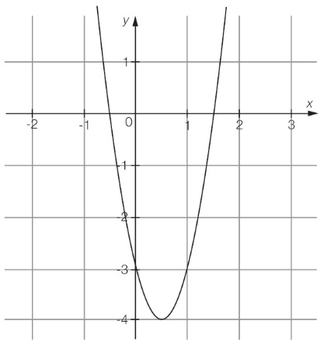

**(a)** the coordinates of the turning point

**(b)** the *x*-intercepts

**(c)** the *y*-intercept

**(d)** the equation of the axis of symmetry.

Question 12 8 marks [9.1]

For the equation *y* = -*x*2 – 6*x* – 10:

**(a)** Complete the table of values.

|  |  |  |  |  |  |  |  |
| --- | --- | --- | --- | --- | --- | --- | --- |
| *x* | - 6 | -5 | - 4 | - 3 | - 2 | -1 | 0 |
| *y* |  |  |  |  |  |  |  |

**(b)** Plot the points on a Cartesian plane and join with a smooth curve.

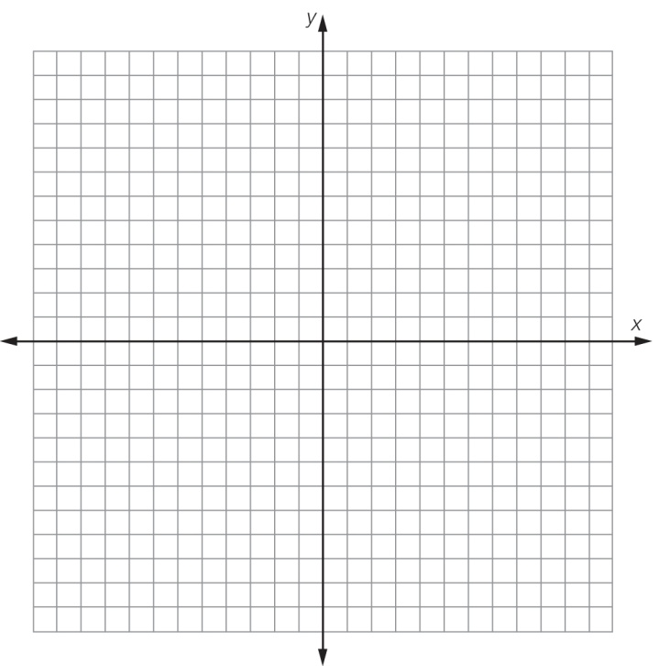

**(c)** Write the coordinates of the turning point.

**(d)** State the nature of the turning point.

Question 13 3 marks [9.2]

Solve the following equations using the null factor law.

**(a)** (*x* – 5) (*x* + 2) = 0

**(b)** *x*2 – 6*x* = 0

**(c)** *x*2 – 49 = 0

Question 14 4 marks [9.2]

Solve the following equations using the null factor law.

**(a)** *x*2 – 12*x* + 27 = 0

**(b)** *x*2 + 3*x* = 10

Question 15 2 marks [9.2]

Use the null factor law to determine the *x*-intercepts for the graph of the equation   
*y* = 4*x*2 + 21*x* + 5.

Question 16 6 marks [9.3]

State the transformations that should be made to the graph of *y* = *x*2 to obtain the graph of each of the following.

|  |  |  |  |  |  |
| --- | --- | --- | --- | --- | --- |
|  | Equation | Dilation  factor | Reflection in *x*-axis? | Horizontal  translation | Vertical translation |
| **(a)** | *y* = (*x* – 4)2 + 1 |  |  |  |  |
| **(b)** | *y* = 2(*x* – 1)2 – 3 |  |  |  |  |
| **(c)** | *y* = -2(*x* + 1)2 + 3 |  |  |  |  |

Question 17 2 marks [9.3]

Find the new equation when the following transformations are performed on the graph of *y* = *x*2.

**(a)** The graph is dilated by a factor of 7, translated 12 units to the left and 8 units up.

**(b)** The graph is dilated by a factor of , translated down 2 units and to the right 1 unit.

Question 18 3 marks [9.4]

Determine the centre and radius of the following circle algebraically, and hence determine the equation of the circle.

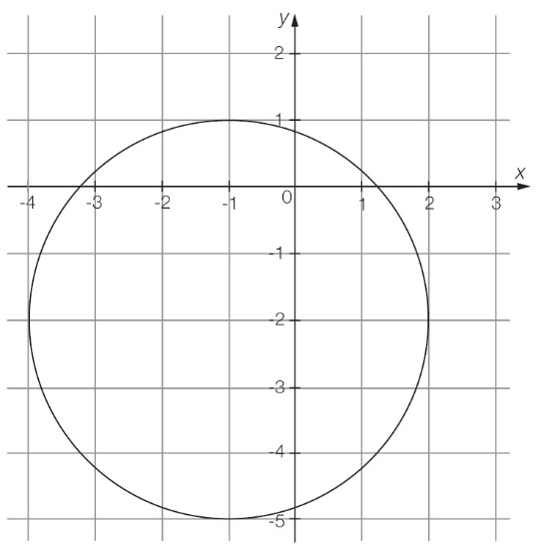

Question 19 1 marks [9.4]

A circle has the equation (*x* + 5)2 + (*y* +3)2 = 36. What would the equation of this circle be if it is translated 2 units left and 6 units up and the radius is decreased by 1 unit?

Question 20 4 marks [9.5]

Consider the following graph:

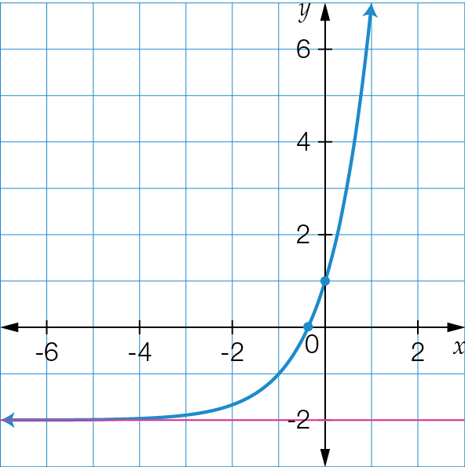

**(a)** What type of relationship does this graph represent?

**(b)** What is the value of the y-intercept for this graph?

**(c)** What is the name of the horizontal line passing through *y* = -2?

**(d)** What is the function of the line in **(c)**?

Question 21 5 marks [9.6]

Consider the following table:

|  |  |  |  |  |
| --- | --- | --- | --- | --- |
| *x* | 2 |  | 6 | 10 |
| *y* | 8 | 20 | 24 |  |

**(a)** Circle the correct description of the relationship between *x* and *y*. Give reasons for your answer.

*y* is directly proportional to *x* OR *y* is inversely proportional to *x*

**(b)** Find the constant of proportionality *k* for this relationship.

**(c)** Use your value for *k* to find the missing values in the table.

Short answer results: ___ / 41

Extended answer section

Question 22 8 marks [9.1]

A ball that is thrown follows a parabolic path where its height above the ground (*h* in metres) at any time (*t* in seconds) is given by the relationship *h* = -*t*2 + 4*t*.

**(a)** Complete the table of values for this relationship.

|  |  |  |  |  |  |
| --- | --- | --- | --- | --- | --- |
| *t* | 0 | 1 | 2 | 3 | 4 |
| *h* |  |  |  |  |  |

**(b)** Plot the graph of this relationship clearly showing:

**(i)** the turning point

**(ii)** *x*-intercepts

**(iii)** *y*-intercept.

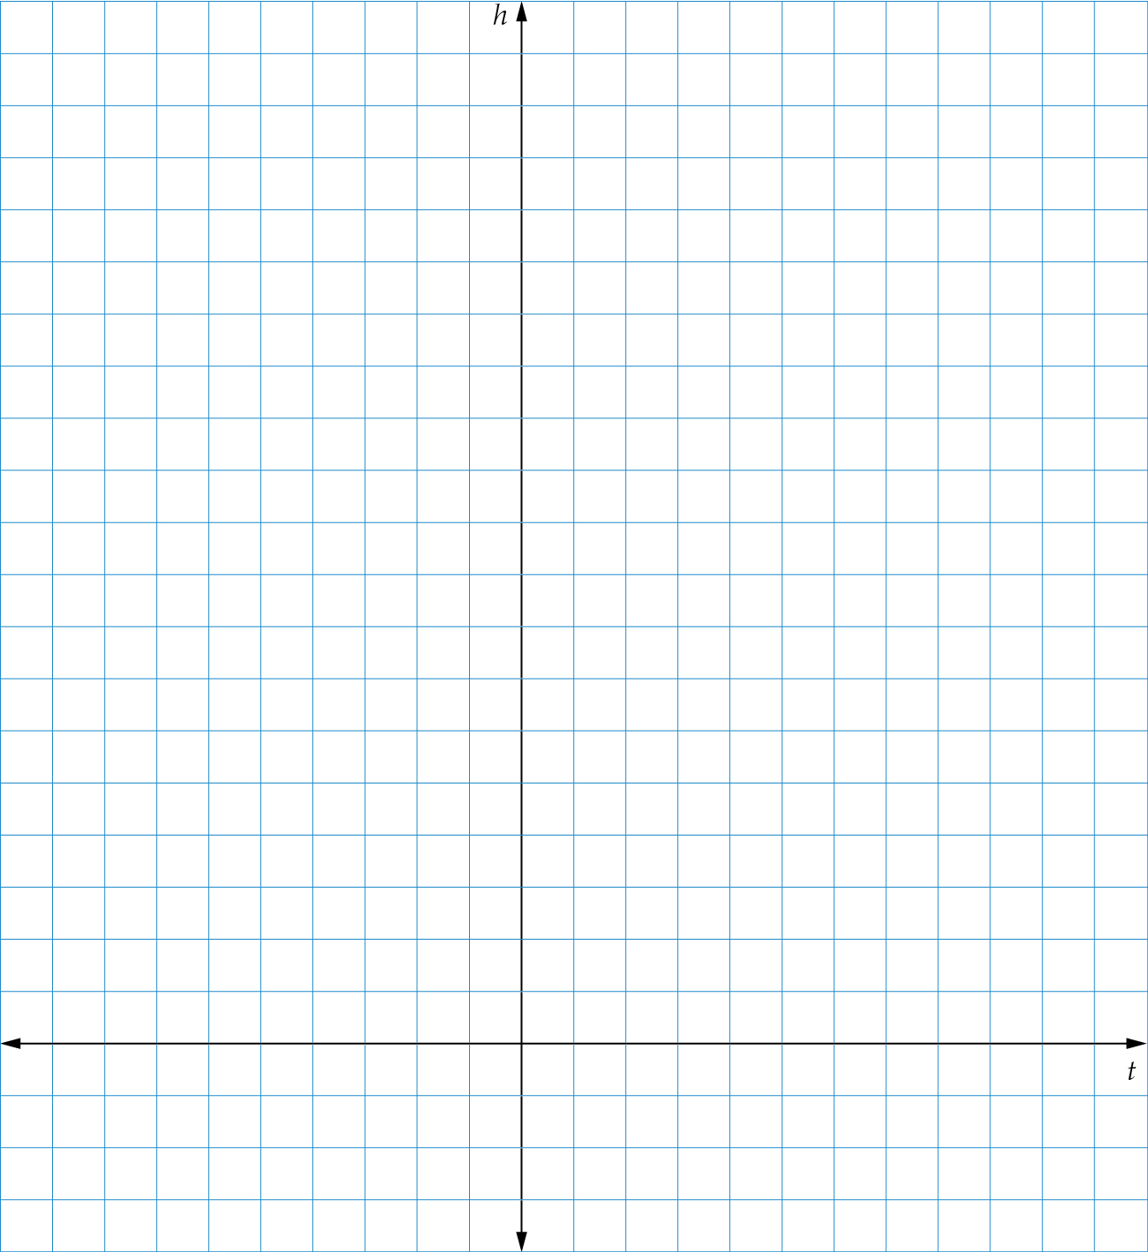

**(c)** What is the maximum height of the ball?

**(d)** At what time does the ball reach its maximum height?

**(e)** When does the ball hit the ground?

**(f)** When is the ball 3 metres from the ground?

Question 23 8 marks [9.4]

A kite is inscribed inside a circle. The kite’s vertices are at *A*(3, 5), *B*(1, 3), *C*(3, 1) and *D*(5, 3) and lie on the circumference of the circle.

**(a)** Draw a diagram of the circle and kite. Shade the kite.

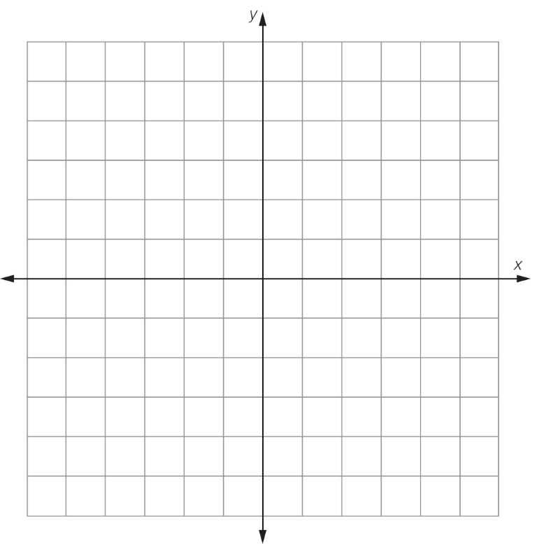

**(b)** What is the equation of the circle?

**(c)** If the kite represents a concreted area and the surrounding parts of the circle represent a garden bed, what is the area of the garden bed? State your answer correct to 3 decimal places.

Question 24 6 marks [9.5]

**(a)** A rectangular hyperbola has asymptotes at *x* = 2 and *y* = 1. Assuming *a* = 1, determine the equation of the graph.

**(b)** What is the value of the *x*-intercept of the hyperbola?

**(c)** What is the value of the *y*-intercept of the hyperbola?

**(d)** Provide a sketch of your equation in **(a)**,clearly showing all key features.

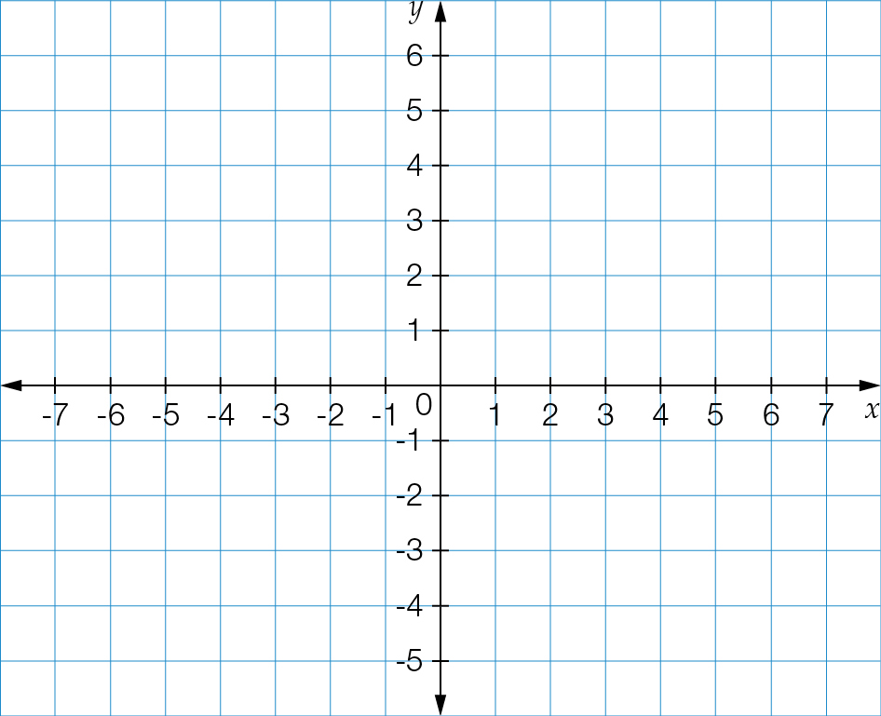

Question 25 8 marks [9.5] [9.6] [9.7]

The pressure of an amount of gas inside a scuba diving tank decreases as the volume of the tank increases.

**(a)** Is this relationship an example of direct or inverse proportion? Explain your answer.

**(b)** The pressure of the air inside a tank with a volume of 20 L is 250 kPa. Using your answer above, find the constant of proportionality.

**(c)** Determine the equation for this relationship.

**(d)** Complete the table:

|  |  |  |  |  |
| --- | --- | --- | --- | --- |
| Volume (*V*) | 2 | 4 | 8 | 10 |
| Pressure (*P*) | 2500 | 1250 |  |  |

**(e)** Plot the graph of volume against pressure.

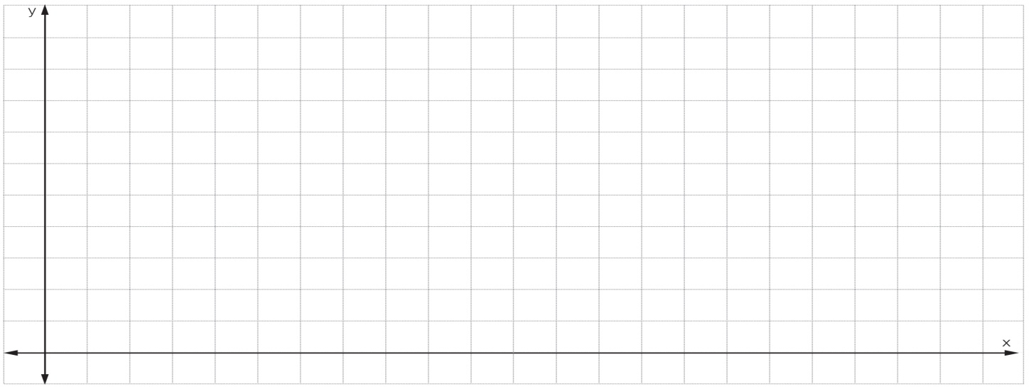

**(f)** How does the shape of your graph confirm your answer in **(a)** above?

**(g)** When the pressure is 2000 kPa, what is the volume?

Extended answer results: ___ / 30

TOTAL test results: ___ / 81